**USER GUIDE**

- First, our website is a website about selling sportswear to them.

-When entering the interface of the homepage, we can see a summary of the site and things like the image of the service displayed on it.

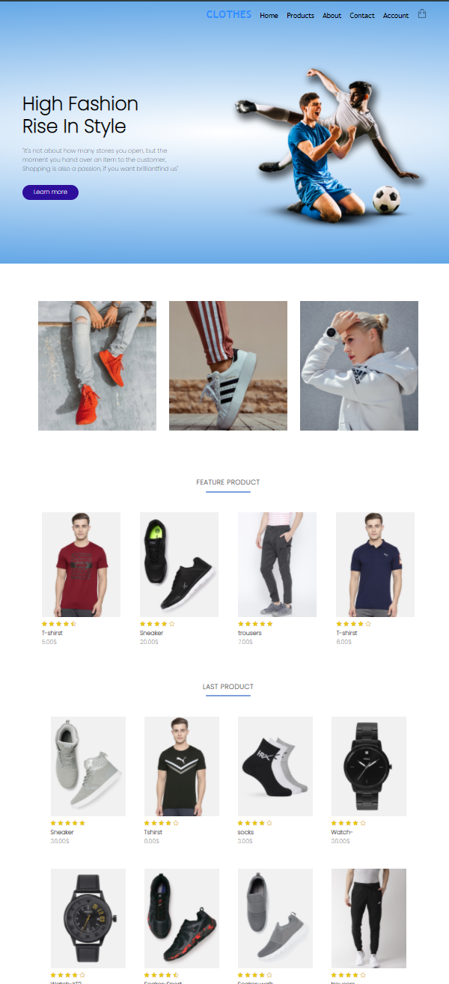

Homepage will show you some new product

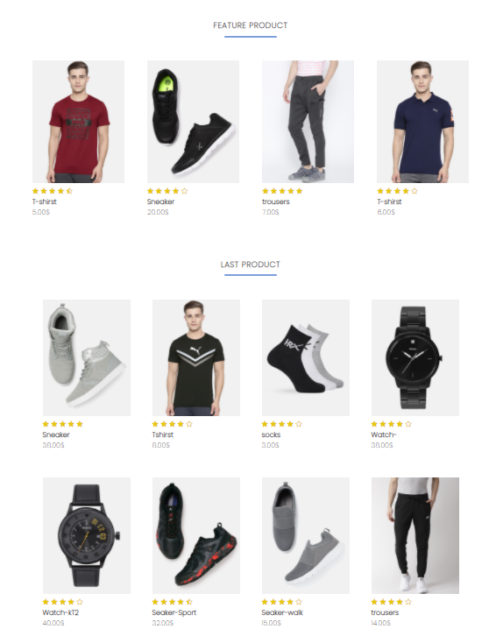

You can compare products by clicking this icon, then a message will appear.

And you can add product to the cart by clicking on this icon.

And if you want to see product details, click on the eye icon in the middle of the product image.

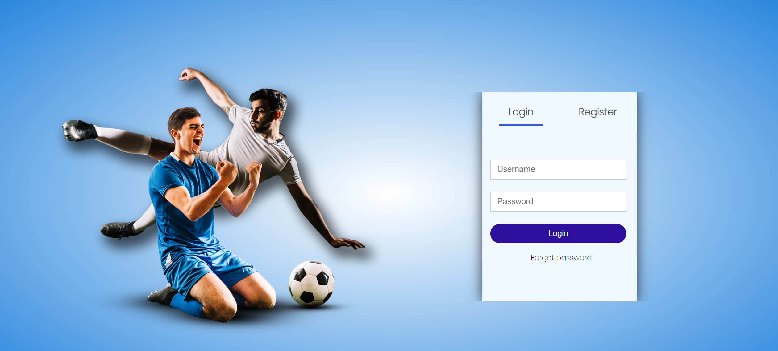

Login Page

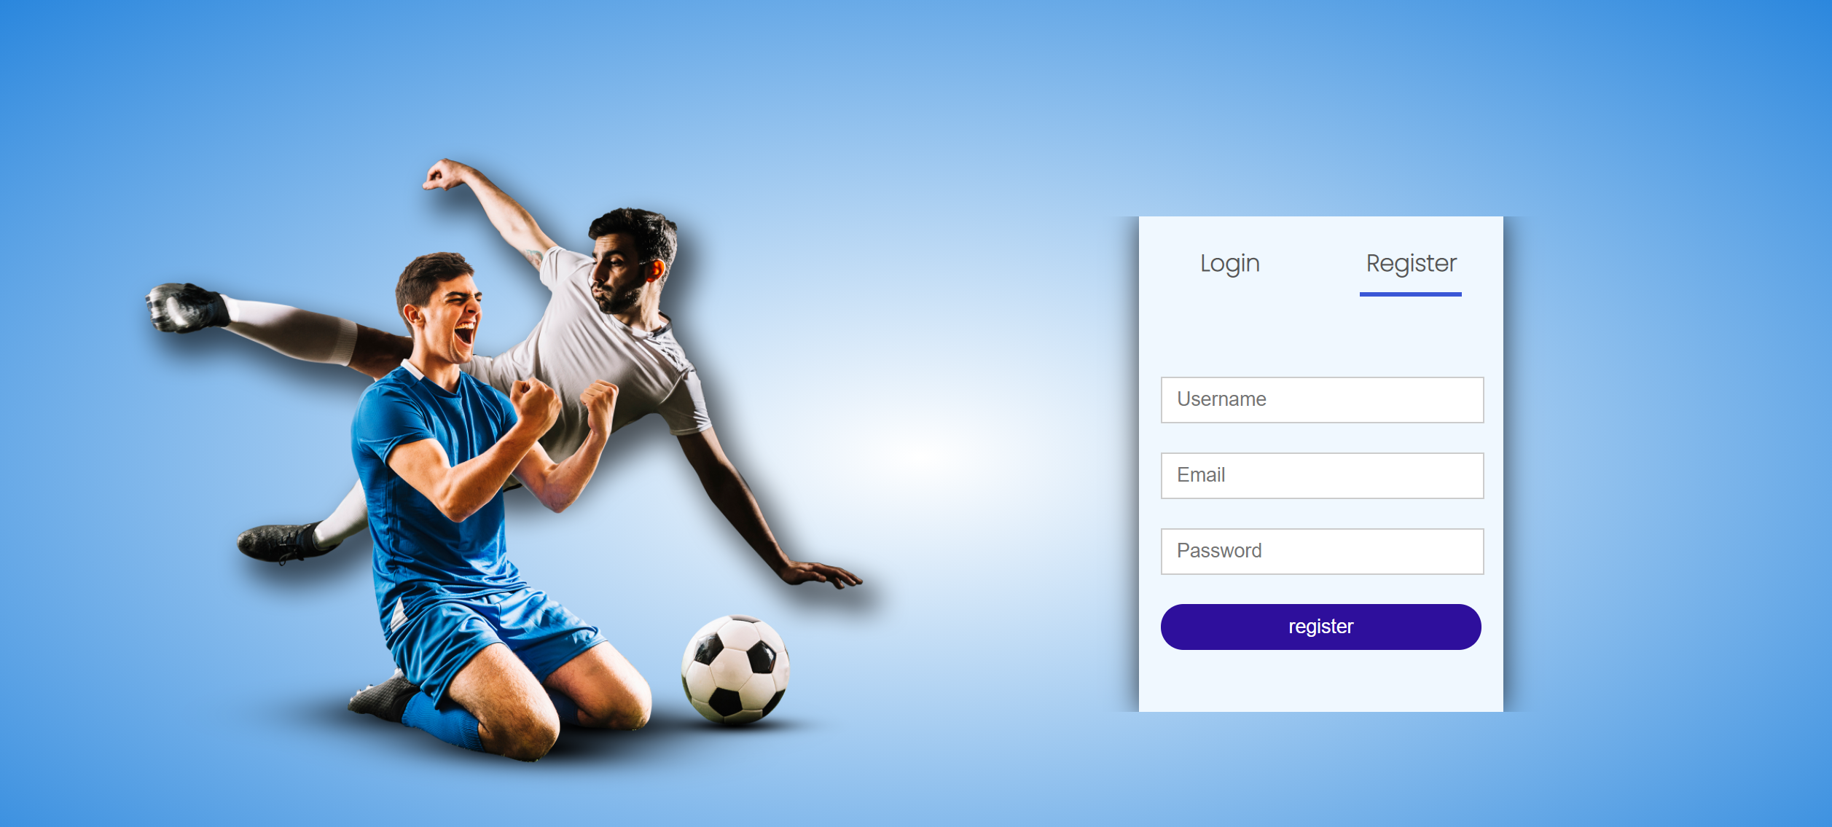

Sign up for Guest

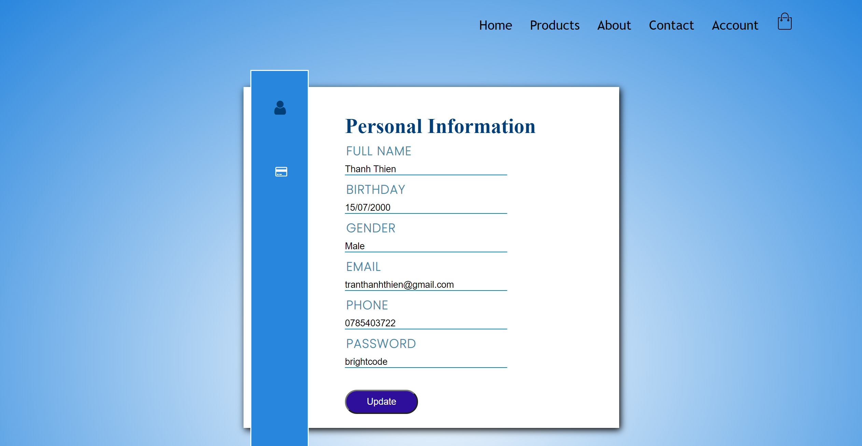

Account information.

Link to login admin page: [http://localhost:8080/ClothesShop/Admin/Login](http://localhost:8080/NHLSport/Admin/Login)

Email: [admin@gmail.com](mailto:admin@gmail.com)

Password: 123456

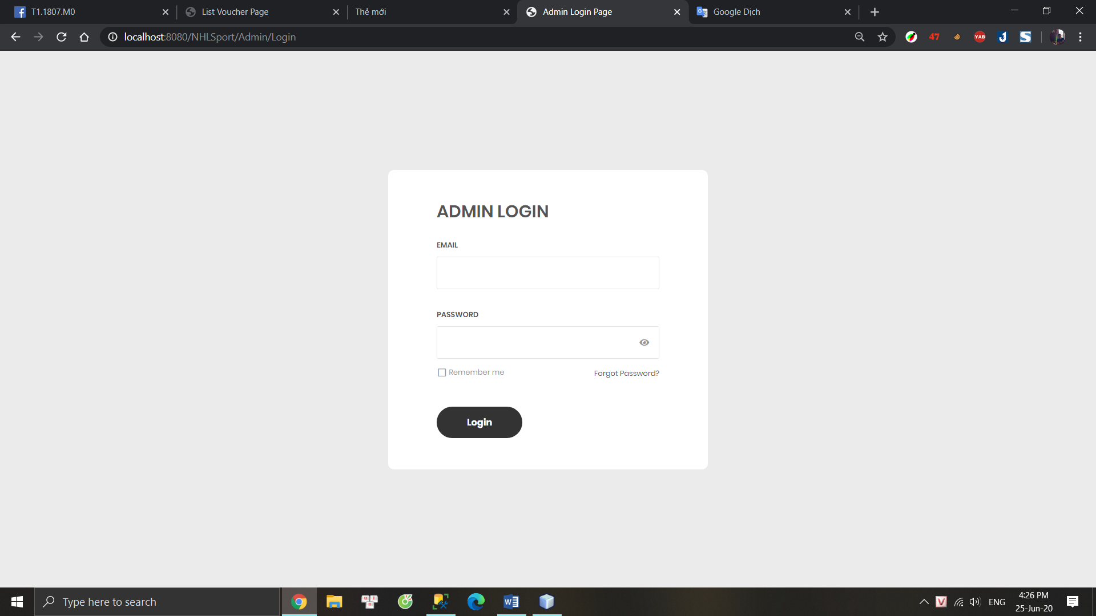

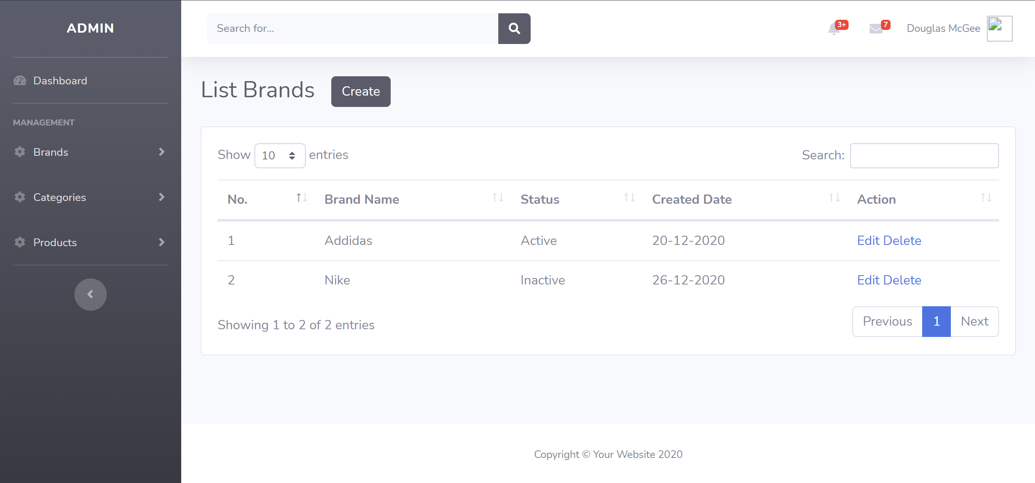

Managed Customers, Brand, Product, category ….

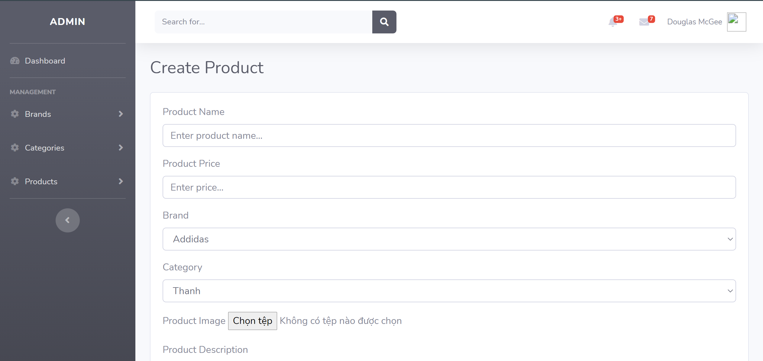

Create new product